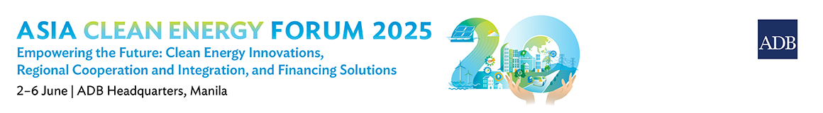

**ACEF 2025 Sponsorship - Expression of Interest[1]**

|  |  |  |  |  |  |  |  |  |  |  |  |  |  |  |  |
| --- | --- | --- | --- | --- | --- | --- | --- | --- | --- | --- | --- | --- | --- | --- | --- |
| |  | | --- | | Title (Ms. /Mr. /Mrs. /Other): | | Name: (Surname) (Given name) (Middle name) | | Position title or designation: | | Name of institution, organization, or company: | | Website of institution/organization/company: | | Office address: | | Country(ies) where the company operates: | | Office telephone no: | | Mobile no: | | E-mail Andress: | | Short description of institution/organization/company: | | Please attach your company profile along with the list of your Board of Directors. | | I am interested in (please tick one):  Silver sponsorship package  Gold sponsorship package  Platinum sponsorship package | | Why is your company interested to be one of the sponsors of ACEF 2025? | |  |

**Please express your interest by 10 Aprilh 2025. For more information on sponsorship packages, please contact Michelle Lyn Visaya (**[**mvisaya.consultant@adb.org**](mailto:mvisaya.consultant@adb.org)**) and Maria Dona Aliboso** [**(daliboso@adb.org**](mailto:daliboso@adb.org)**).**

1. *Sponsorship applications will undergo a thorough evaluation by ADB to verify that the applicant is not included in any sanctions list of ADB or other international organizations.*